Department of Artificial Intelligence and Machine Learning

Object Oriented Programming through C++

CERTIFICATE
This is to certify that the Cornerstone project work entitled “MATRIX OPERATIONS
SYSTEMS”. A C++ - based Matrix Operations, Analysis and Computation System is submitted by:

J.GIREESH - (25B11AI427)
G.SATISH - (25B11AI367)
K.SAI VINAY - (25B11AI492)
N.BHARATH VENKATA PAVAN - (26B21AI084)

In partial fulfilment of the requirements for the award of the B.Tech. degree in Artificial intelligence and machine learning the academic year 2026-2027.

Project Guide Head of the Department
Thorati Vijaya lakshmi, Dr. K. Naga Bhargavi, Ph.D,
Assistant Professor, Associate Professor & HOD,
Department of AIML. Department of AIML.

CERTIFICATE

This is to certify that the Cornerstone Project entitled “Matrix Operations System” is submitted by the students of the Department of Computer Science & Engineering, Aditya University, in partial fulfilment of the academic requirements for the B.Tech. degree.
The project has been developed as part of the course Object Oriented Programming through C++. The work presented in this documentation describes the planning, implementation, testing and current scope of the Matrix Operations System developed by the project team.
The project work has been carried out under the prescribed academic guidance and is presented for evaluation as a Cornerstone Project.

DECLARATION

We hereby declare that the project entitled “Matrix Operations System” is our original academic work carried out as part of the Cornerstone Project for Object Oriented Programming through C++ at Aditya University.
We further declare that this project has been prepared for academic evaluation and has not been submitted, either in full or in part, for the award of any other degree or diploma. The work has been carried out with academic honesty and with appropriate acknowledgement of the resources used during development.
We accept responsibility for the accuracy of the project information, implementation details and documentation presented in this report.

SUBMITTED BY

J. GIREESH - (25B11AI427)
G. SATISH - (25B11AI367)
K. SAIVINAY - (25B11AI492)
N.B.V.PAVAN - (26B21AI084)

ACKNOWLEDGEMENT

It is with immense pleasure that we express our sincere gratitude to our Cornerstone Project Guide, Thorati Vijaya lakshmi, Assistant Professor, who has guided us throughout the project. His valuable support, encouragement, and guidance have greatly contributed to the successful completion of this work.
We would like to thank our Deputy Heads of the Department, Dr. R. Suneetha , Assistant Professor, Dr. Bollu Manikyala Rao, Assossicate Professor and Dr. Dasari Veeraswamy, Assistant Professor, Department of AIML, for their support and valuable suggestions.
Our deepest thanks to our Head of the Department, Dr. Kovvuri N Bhargavi, Associate Professor & HOD, for her inspiration and for providing all the necessary facilities and resources required for this project.
We also extend our sincere thanks to Dr. M.V. Rajesh, Associate Dean, School of Computing, for his encouragement and support during our project.
We would like to express our sincere gratitude to Dr. G. Suresh, Registrar; Dr. A. Ramesh, Pro Vice-Chancellor (Engineering & Sciences); Dr. S. Rama Sree, Pro Vice-Chancellor (Academics); Dr. M.B. Srinivas, Vice-Chancellor; and Dr. M. Sreenivasa Reddy, Deputy Pro Chancellor and Management, Aditya University, for providing excellent infrastructure and state-of-the-art laboratories
Finally, we would like to thank the faculty members, lab technicians, nonteaching staff, and our friends who have directly or indirectly supported us in completing this Cornerstone project successfully.

ABSTRACT

The Matrix Operations System is an educational and interactive web-based application developed as a Cornerstone Project for the course Object Oriented Programming through C++. The primary purpose of the system is to provide a single platform where users can learn fundamental matrix concepts, understand different types of matrices and perform selected matrix operations through an interactive calculator.
The educational component introduces matrices, their notation, rows, columns, elements and order. It also explains several important matrix types, including row, column, rectangular, square, zero, diagonal, scalar, identity, upper triangular, lower triangular, symmetric, skew-symmetric, singular, non-singular, idempotent, nilpotent, involutory and orthogonal matrices.
The practical component provides a Matrix Calculator for Matrix Addition, Matrix
Multiplication and Matrix Transpose. The frontend is designed using HTML, CSS and JavaScript, while the actual matrix calculations and validation are handled by a C++ backend. The C++ implementation is organized around a Matrix class so that the project demonstrates classes, objects, encapsulation, constructors and member functions.
The current version is intentionally focused on a clear and manageable set of features. The modular structure allows additional mathematical operations and advanced functionality to be introduced in later versions.

ABBREVIATIONS

Abbreviations | Description
OOP | Object Oriented Programming
C++ | C Plus Plus
API | Application Programming Interface
REST | Representational State Transfer
JSON | JavaScript Object Notation
HTML | HyperText Markup Language
CSS | Cascading Style Sheets
JS | JavaScript
UI | User Interface
CSE | Computer Science & Engineering
IDE | Integrated Development Environment
HTTP | HyperText Transfer Protocol

LIST OF FIGURES

Figure 1. High-Level System Architecture
Figure 2. Matrix Operation Flow / System Flowchart
Figure 3. OOP Design of the Matrix Class
Figure 4. Boolean Matrix Calculator
Figure 5. Frontend–Backend API Communication
Figure 6. Website Navigation Structure
Figure 7. Matrix Calculator – Addition
Figure 8. Matrix Calculator – Multiplication
Figure 9. Matrix Calculator – Transpose
Figure 10. Invalid Input / Validation Result

LIST OF TABLES

Table 1. Current Scope
Table 2. Technology Stack
Table 3. Backend API
Table 4. Validation and Error Handling
Table 5. Validation and Error Handling

TABLE OF CONTENTS

CONTENTS | PAGE NO
Title Page | I
Certificate | II
Declaration | III
Acknowledgement | IV
Abstract | V
Abbreviations | VI
List of Figures | VII
List of Tables | VIII
Table of Contents | IX
CHAPTER – 1 PROJECT PLANNING | 1
1.1 Problem Statement and Scope | 1
1.2 Project Objectives | 2
1.3 Planned Modules | 3-4
1.4 System Architecture | 5
1.5 Algorithms and Flowchart | 6
CHAPTER – 2 PROJECT IMPLEMENTATION | 7
2.1 OOP Concepts Used for Implementation | 7
2.2 Technology Stack and Project Structure | 8
2.3 Matrix Class and Core Functions | 9-10
2.4 Matrix operations | 11
2.5 Boolean Matrix Operations | 12
2.6 Backend REST API | 13
2.7 Validation and Error Handling | 14
2.8 Frontend Pages and User Interface | 15
2.9 Testing and Outputs | 16-18
CHAPTER – 3 CONCLUSION & FUTURE SCOPE | 19
3.1 Conclusion | 19
3.2 Future Scope | 20
References | 21

The documentation is organized into three main chapters. Chapter 1 presents the project planning, problem statement, objectives, modules, architecture and algorithms. Chapter 2 describes the implementation, including the C++ object-oriented design, technology stack, matrix functions, backend API, validation, frontend pages and testing. Chapter 3 summarizes the project and identifies possible future enhancements.

CHAPTER – 1 PROJECT PLANNING
1.1 Problem Statement
Matrices are fundamental mathematical structures used in engineering, computer science, computer graphics, artificial intelligence, data analysis and scientific computing. Although the basic definition of a matrix is simple, students must understand several related concepts such as matrix order, special matrix types, matrix properties and operation conditions.
A common difficulty is that matrix concepts are often learned separately from practical calculation. Students may understand a formula but still find it difficult to connect the formula with an actual matrix. Manual calculations also become repetitive and errorprone when the matrix size increases.
The Matrix Operations System addresses this learning gap by combining educational material with an interactive calculator. The website explains the concepts before allowing users to perform selected calculations. The current implementation focuses on Matrix Addition, Matrix Multiplication and Matrix Transpose, while the educational section provides broader coverage of matrix types and operations.
Project Scope
- The system explains matrix fundamentals and important matrix properties.
- The website provides dedicated educational content for different matrix types.
- The calculator accepts matrix dimensions and elements from the user.
- The C++ backend performs the actual matrix calculations.
- The system validates incompatible dimensions and invalid inputs.
- The interface supports Light Mode and Dark Mode settings.
- The design is modular so that future matrix features can be added.
Table 1. Current Scope
Area | Current Scope
Learning | Matrix basics, 18 matrix types and operation rules
Computation | Addition, multiplication, transpose and Boolean operations
Backend | C++17, Matrix class, Crow REST API and JSON
Frontend | HTML5, CSS3 and Vanilla JavaScript
Build/Deployment | CMake build and Dockerfile-based container setup

1.2 Project Objectives
The project is designed with both educational and implementation objectives. The educational objectives focus on presenting matrix concepts in a structured and understandable manner. The implementation objectives focus on applying C++ objectoriented programming concepts to real matrix operations.
- To explain the definition, notation, elements, rows, columns and order of matrices.
- To introduce common, special and property-based matrix types with examples.
- To explain the conditions required for basic matrix operations.
- To implement Matrix Addition using C++.
- To implement Matrix Multiplication using C++.
- To implement Matrix Transpose using C++.
- To perform input and dimension validation before calculation
- To demonstrate classes, objects, encapsulation, constructors and member functions.
- To provide a responsive educational interface that is simple to navigate.
- To create a modular foundation for future enhancements.
1.3 Planned Modules
The website is organized into clearly defined pages so that educational content and practical calculation remain easy to access. The navigation is intentionally simple and does not overload the homepage with separate operation widgets.
Home
The Home page introduces the Matrix Operations System and explains what a matrix is. It presents a short introduction to rows, columns and matrix notation and provides navigation to the learning and calculator sections.
Matrix Basics
This section explains matrix elements, rows, columns, notation, order and equality of matrices. Small mathematical examples are used to make the definitions easier to understand.
Types of Matrices
This section covers row, column, rectangular, square, zero, diagonal, scalar, identity, upper triangular, lower triangular, symmetric, skew-symmetric, singular, non-singular, idempotent, nilpotent, involutory and orthogonal matrices.
Matrix Calculator
The calculator provides interactive input for Matrix Addition, Matrix Multiplication and Matrix Transpose. It is the main functional component of the current version.
Matrix Operations
The operations section explains addition, subtraction, scalar multiplication, multiplication and transpose. It also introduces determinant and inverse as mathematical concepts, even though the current calculator implementation is limited to the selected core operations.
Boolean Calculator
Provides Boolean addition, Boolean subtraction and Boolean multiplication using logical operations
Settings
The Settings page provides Light Mode, Dark Mode and application preferences. The selected theme can be stored locally so that it remains consistent across pages.
About
The About page presents the project objective, technology stack, C++ concepts and team information.
1.4 System Architecture
The system follows a frontend–backend architecture. The frontend provides the user interface and educational content.
JavaScript collects matrix values and communicates with the backend using JSON requests. The C++ backend receives the request, validates the matrix dimensions and performs the required calculation.
The Matrix class forms the central application component in the backend. Matrix data is stored in a structured two-dimensional representation. Separate member functions are used for addition, multiplication and transpose. The result is converted into a JSON response and returned to the frontend for display.
User → Web Interface → JavaScript → JSON Request → C++ Backend → Matrix Class → JSON Response → Result
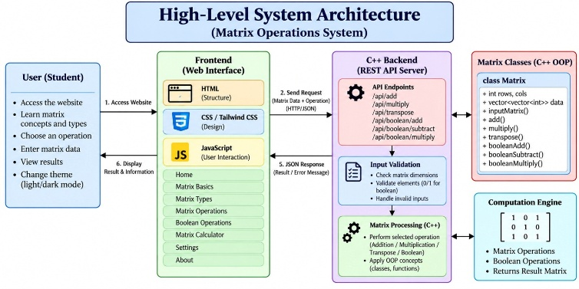
Figure 1. High-Level System Architecture
Architecture Responsibilities
- HTML provides the structure of each page.
- CSS provides layout, typography, responsive design and theme styling.
- JavaScript generates matrix inputs, sends requests and displays results.
- C++ and Crow provide the REST backend.
- The Matrix class contains the matrix data and operations.
- JSON provides a simple format for communication between the frontend and backend.
1.5 Algorithms and Flowchart
Matrix Addition Algorithm
- Start
- Read dimensions and elements of Matrix A and Matrix B.
- Check whether both matrices have the same number of rows and columns.
- If dimensions differ, return an error.
- Otherwise add corresponding elements.
- Store the result in Matrix C.
- Display the result and stop.
- C[i][j] = A[i][j] + B[i][j]
Matrix Multiplication Algorithm
- Read Matrix A and Matrix B.
- Check whether columns of A equal rows of B.
- If not, return a dimension error.
- For each result position, compute the row-column dot product
- Store the result and return it to the caller.
- C[i][j] = Σ A[i][k] × B[k][j]
Transpose Algorithm
- Read Matrix A.
- Create a result matrix with reversed dimensions
- Copy each element from A[i][j] to T[j][i].
- Return the transposed matrix.
- [j][i] = A[i][j]

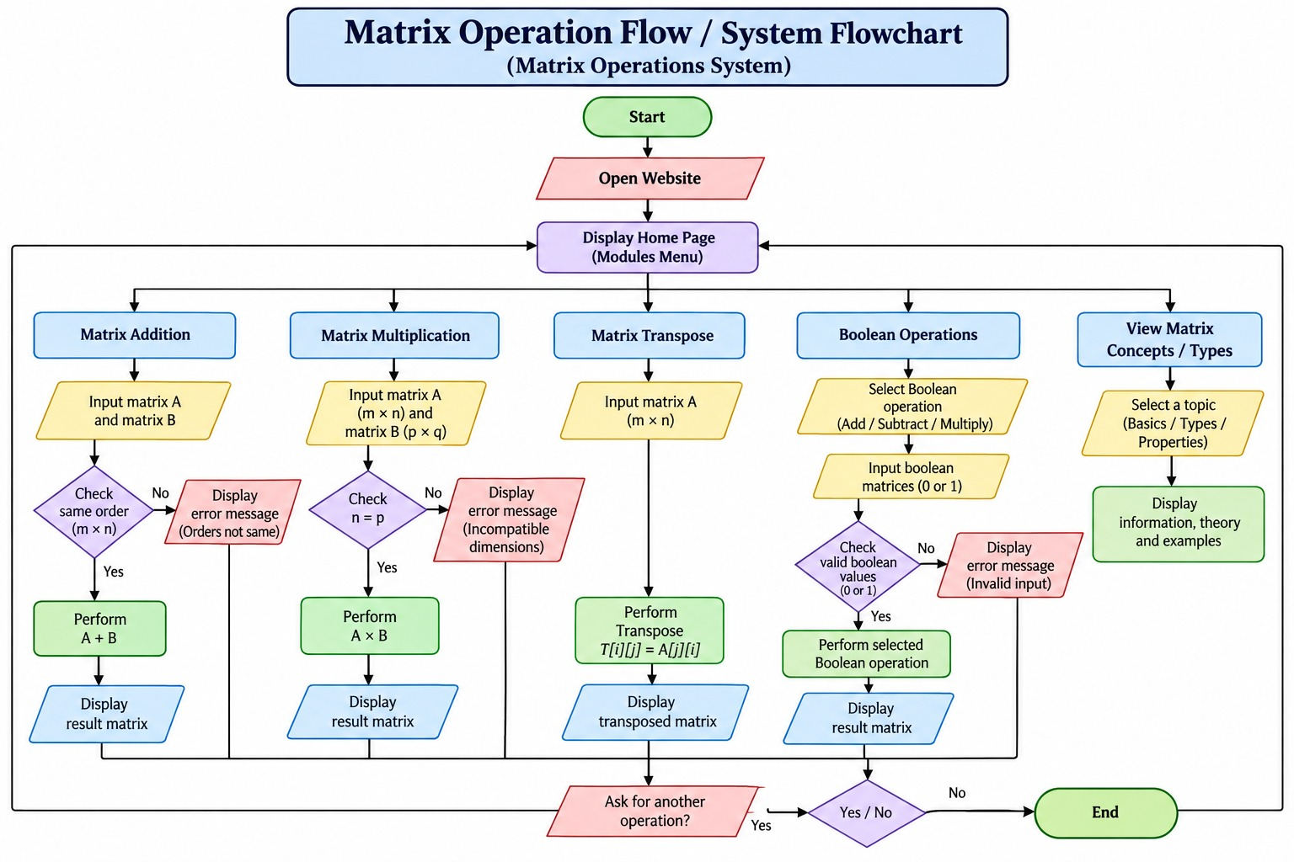
Figure 2. Matrix Operation Flow / System Flowchart

CHAPTER – 2 PROJECT IMPLEMENTATION

2.1 OOP Concepts Used for Implementation
Object Oriented Programming is central to the C++ backend of the project. The Matrix class provides a natural abstraction for matrix data and operations. Instead of placing all calculations in a single function, the project organizes the data and behavior into a reusable class.
Classes and Objects
The Matrix class defines the structure and operations of a matrix. Objects created from the class represent individual matrices such as Matrix A, Matrix B and the resultant matrix.
Encapsulation
Matrix dimensions and stored elements are maintained inside the Matrix class. Public member functions provide controlled access to operations such as addition, multiplication and transpose.
Constructors
Constructors initialize a Matrix object with the required number of rows and columns or with existing matrix values.
Member Functions
Member functions implement the mathematical operations and provide access to required matrix information such as rows and columns.
Access Specifiers
Private members protect the internal matrix representation, while public members provide the operations required by the application.
Exception Handling
std:: invalid_argument is used to report invalid dimensions, incompatible matrices and malformed data.
Modularity
The backend is divided into main application logic and Matrix class implementation.
This makes the project easier to maintain and extend.

2.2 Technology Stack and Project Structure
The frontend is developed using standard web technologies so that the educational pages remain lightweight and easy to maintain. HTML5 defines the page structure, CSS3 provides visual styling and responsive layout, and JavaScript handles user interaction and communication with the backend.
The backend is implemented entirely in C++. The Crow framework is used to expose REST endpoints, while JSON is used for request and response data. CMake is used as the build system so that the C++ project can be compiled in a structured manner.
Table 2. Technology Stack
Layer | Technology | Purpose
Frontend | HTML5 | Page structure and content
Frontend | CSS3 | Responsive styling, themes and layout
Frontend | Vanilla JavaScript | User interaction, matrix grids and API requests
Backend | C++17 | Matrix representation and calculations
Web Framework | Crow v1.2.0 | HTTP routing and REST API handling
Data Exchange | JSON | Request and response format
Build | CMake | C++ project configuration and compilation
Deployment | Docker | Containerized Ubuntu-based build and execution

Project Directory Structure
Matrix-Operations-System/
├── frontend/
│ ├── index.html, home.html, basics.html, types.html
│ ├── operations.html, calculator.html, boolean-calculator.html
│ ├── settings.html, about.html, profile.html, signup.html
│ ├── css/style.css
│ └── js/main.js, calculator.js, boolean-calculator.js, settings.js
├── backend/
│ ├── main.cpp
│ ├── Matrix.h
│ ├── Matrix.cpp
│ └── CMakeLists.txt
├── CMakeLists.txt
├── Dockerfile
└── README.md
2.3 Matrix Class and Functions
The Matrix class is responsible for representing a matrix and performing operations. A two-dimensional vector is suitable for the current implementation because it provides dynamic matrix dimensions and keeps the code readable.
class Matrix {
private:
int rows;
int cols;
std::vector<std::vector<double>> data;
public:
Matrix();
Matrix(int rows, int cols);
Matrix(const std::vector<std::vector<double>>& grid);
int getRows() const;
int getCols() const;
const std::vector<std::vector<double>>& getData() const;
Matrix add(const Matrix& other) const;
Matrix multiply(const Matrix& other) const;
Matrix transpose() const;
Matrix booleanAdd(const Matrix& other) const;
Matrix booleanSubtract(const Matrix& other) const;
Matrix booleanMultiply(const Matrix& other) const; };
Matrix Addition
Matrix addition is possible only when both matrices have the same order. The corresponding elements are added and stored in a new result matrix. result[i][j] = A[i][j] + B[i][j]
Matrix Multiplication
Matrix multiplication is possible when the number of columns in the first matrix equals the number of rows in the second matrix. Each result element is obtained from the dot product of a row and a column. result[i][j] += A[i][k] * B[k][j]
Matrix Transpose
Transpose interchanges the row and column position of each element.
transpose[j][i] = A[i][j]
Constructor Validation
The dimension constructor rejects non-positive dimensions and dimensions greater than 1000 × 1000. The vector-based constructor rejects empty matrices, inconsistent row lengths and oversized matrices. These checks prevent invalid Matrix objects from entering the calculation layer.
OOP Design Diagram
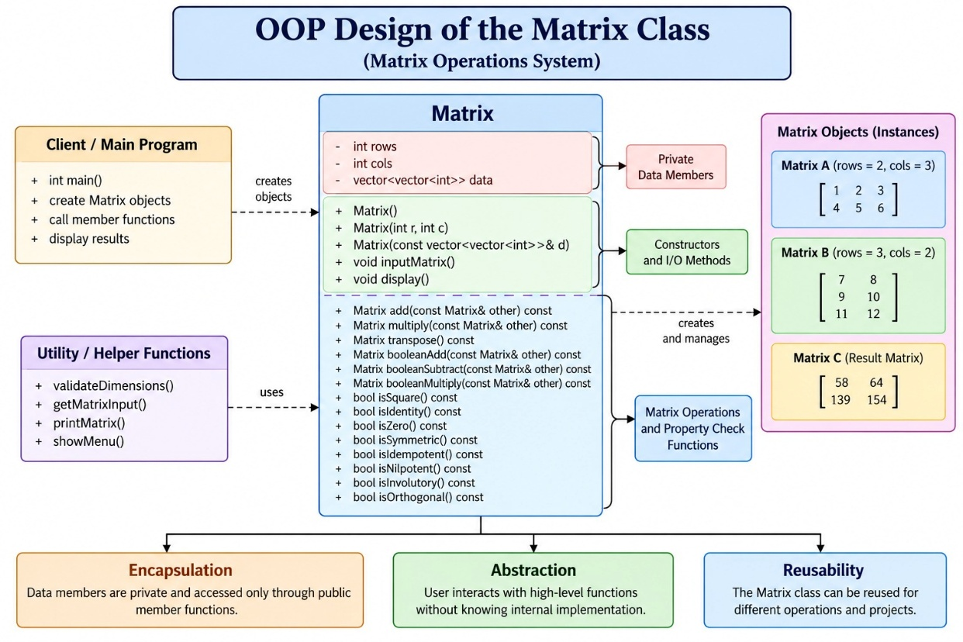 Figure 3. OOP Design of the Matrix Class

2.4 Matrix Operations
Matrix Addition
Matrix addition is valid only when both matrices have identical dimensions. The implementation creates a result matrix and adds corresponding elements.
Matrix Matrix::add(const Matrix& other) const {
if (rows != other.getRows() || cols != other.getCols())
throw std::invalid_argument("Both matrices must have the same dimensions.");
Matrix result(rows, cols);
for (int i=0; i<rows; ++i)
for (int j=0; j<cols; ++j)
result.data[i][j] = data[i][j] + other.data[i][j];
return result;
}
Matrix Multiplication
Matrix multiplication is valid when the number of columns in Matrix A equals the number of rows in Matrix B. Each result element is calculated using the dot product of one row and one column.
for (int i=0; i<rows; ++i)
for (int j=0; j<other.getCols(); ++j) {
double sum = 0.0;
for (int k=0; k<cols; ++k)
sum += data[i][k] * other.data[k][j];
result.data[i][j] = sum;
}
Matrix Transpose
Transpose exchanges the row and column positions of every element. A matrix of order m × n produces a transpose of order n × m.
result.data[j][i] = data[i][j];

2.5 Boolean Matrix Operations
The current uploaded source contains a separate Boolean Matrix Calculator and three Boolean operations exposed by the C++ backend. Boolean values are derived from whether each numeric matrix element is zero or non-zero.
Boolean Addition (Logical OR)
For Boolean addition, corresponding elements are treated as Boolean values. The result is 1 when either input element is non-zero; otherwise it is 0. Both matrices must have the same dimensions.
bool a = data[i][j] != 0;
bool b = other.data[i][j] != 0;
result.data[i][j] = (a || b) ? 1.0 : 0.0;
Boolean Subtraction (A AND NOT B)
The project implements Boolean subtraction as logical difference: an output element is 1 when the corresponding element of A is non-zero and the corresponding element of B is zero.
result.data[i][j] = (a && !b) ? 1.0 : 0.0;
Boolean Multiplication
Boolean multiplication follows the matrix compatibility rule and uses logical AND within the row-column combination. The result becomes 1 if at least one compatible pair is simultaneously non-zero.
bool sum = false;
for (int k=0; k<cols; ++k) {
bool a = data[i][k] != 0;
bool b = other.data[k][j] != 0;
if (a && b) { sum = true; break; }}
result.data[i][j] = sum ? 1.0 : 0.
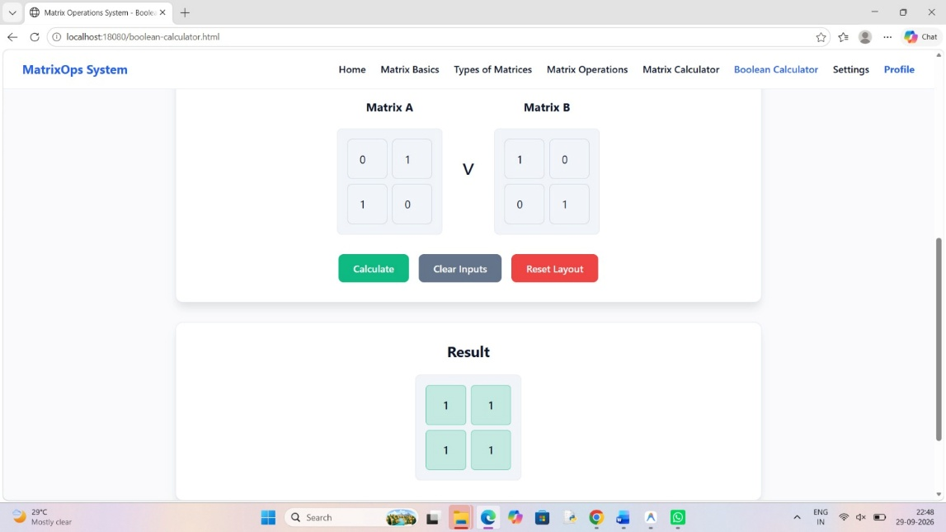0;
Figure 4. Boolean Matrix Calculator
2.6 Backend API
The frontend communicates with the C++ backend through three REST endpoints. Each request contains matrix data in JSON format. The backend validates the data, performs the requested operation and returns a JSON response.
Table 3. Backend API
Method | Endpoint | Input | Purpose
POST | /api/add | matrixA, matrixB | Element-wise addition
POST | /api/multiply | matrixA, matrixB | Conventional matrix multiplication
POST | /api/transpose | matrix | Matrix transpose
POST | /api/bool_add | matrixA, matrixB | Boolean OR addition
POST | /api/bool_sub | matrixA, matrixB | Boolean difference
POST | /api/bool_multiply | matrixA, matrixB | Boolean matrix multiplication

Example Request and Response
POST /api/add
{
"matrixA": [[1,2],[3,4]],
"matrixB": [[5,6],[7,8]]
}
Response:
{
"success": true,
"result": [[6,8],[10,12]]
}

Request Handling
main.cpp includes helper functions for converting JSON matrices into std::vector<std::vector<double>> and for serializing calculated data back into Crow JSON values. Missing fields, malformed JSON and exceptions are converted into error responses.

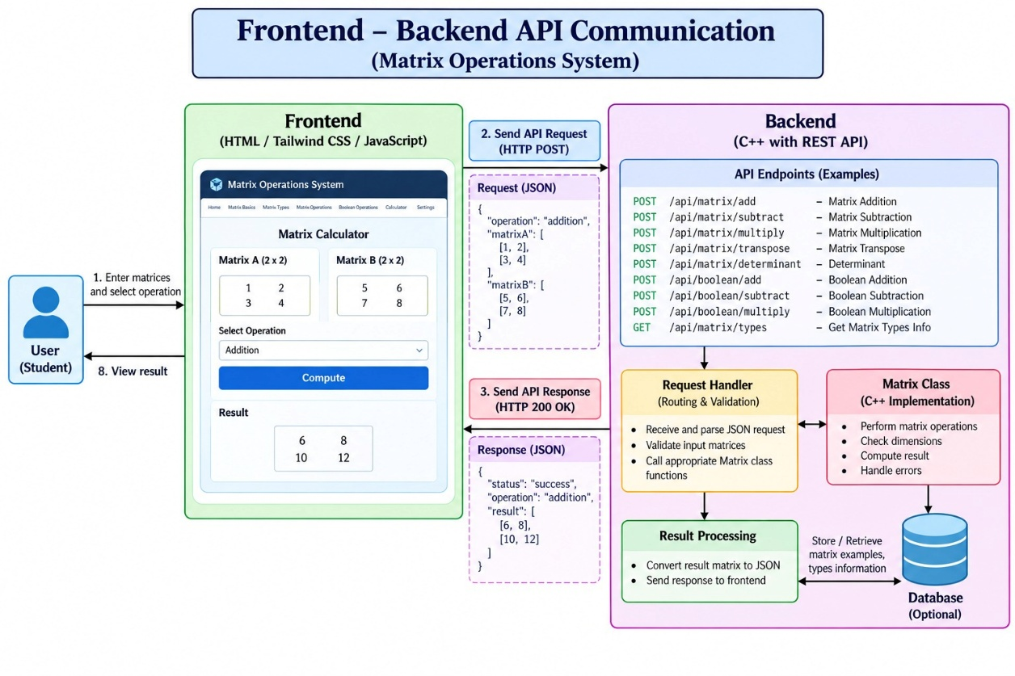
Figure 5. Frontend–Backend API Communication
2.7 Validation and Error Handling
Validation is performed before the C++ calculation. Frontend checks improve the user experience, while backend validation provides the final protection against invalid matrix requests. This prevents incompatible matrices from reaching the calculation logic.

Tables 4. Validation and Error Handling
Condition | Validation Rule | Representative Error
Empty matrix | Reject empty matrix data. | Cannot create an empty matrix.
Non-positive dimensions | Reject rows or columns ≤ 0. | Matrix dimensions must be strictly positive.
Oversized matrix | Reject dimensions above 1000 × 1000. | Matrix dimensions exceed the maximum allowed limit.
Unequal row lengths | Reject irregular 2D vectors. | Inconsistent number of columns in the provided grid.
Addition mismatch | Rows/columns must match. | Both matrices must have the same dimensions.
Multiplication mismatch | A columns must equal B rows. | Columns of Matrix A must equal rows of Matrix B.
Invalid JSON | Reject malformed request bodies. | Invalid JSON.
Missing fields | Reject absent matrixA/matrixB or matrix. | Missing matrix data.

Exception Handling
The Matrix class uses std::invalid_argument for invalid matrix state and incompatible operations. Each API route catches standard exceptions and returns an HTTP 400 response with a success flag set to false and an explanatory error message.
try {
Matrix resultMat = matA.multiply(matB);
response["success"] = true;
response["result"] = serializeMatrixJson(resultMat.getData());
return crow::response(200, response);
} catch (const std::exception& e) {
response["success"] = false;
response["error"] = e.what();
return crow::response(400, response);
}

CORS Support
The backend defines a CORS middleware that allows the frontend to communicate with the API. OPTIONS routes are provided for API preflight requests
2.8 Frontend Pages and User Interface
The project contains multiple HTML pages. The frontend is intentionally separated from the C++ computational layer so that users can learn matrix concepts and interact with the calculator through a browser.

Table 5. Validation and Error Handling
Page | Purpose
index.html | Login interface / entry page
home.html | Introduction and uses of matrices
basics.html | Matrix definition, notation, rows, columns, elements, order and equality
types.html | 18 types of matrices and examples
operations.html | Guide to matrix operations and mathematical rules
calculator.html | Conventional matrix calculator
boolean-calculator.html | Boolean matrix calculator
settings.html | Appearance and matrix preferences
about.html | Project, technologies and C++ concepts
profile.html | Profile interface
signup.html | Sign-up interface

Calculator Interaction
- The user selects an operation and enters matrix dimensions.
- JavaScript dynamically creates input grids for Matrix A and Matrix B.
- Input values are checked for empty and non-numeric fields.
- The browser sends the matrix data to the corresponding C++ API endpoint as JSON
- . The backend performs the calculation and returns the result.
- JavaScript renders the returned matrix in the result grid and displays validation messages when required.

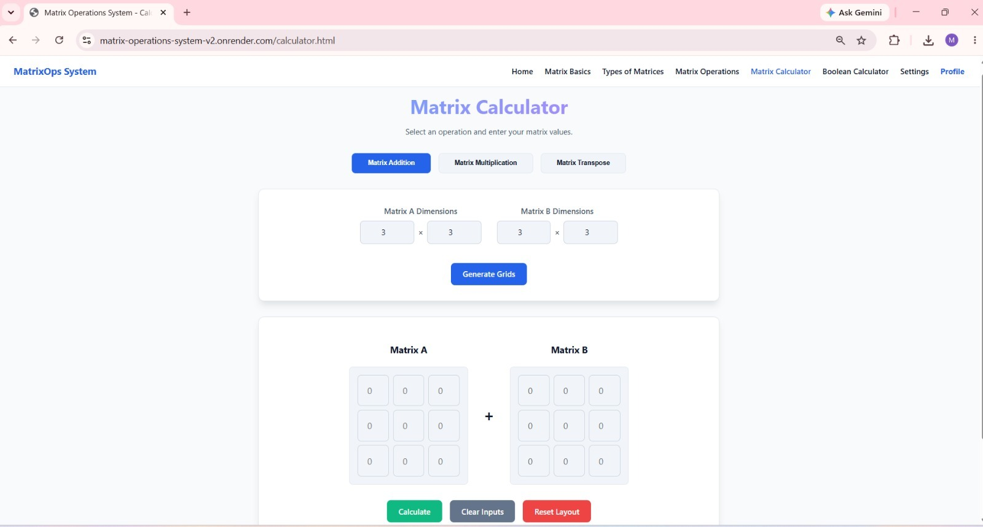Figure 6. Website Navigation Structure
Theme and Preferences
The settings frontend provides appearance and matrix preference controls. The calculator JavaScript also reads maximum row and column preferences from localStorage, allowing the interface to enforce a user-configured input limit before a request is sent.
2.9Testing and Outputs
Testing is required to confirm that the mathematical operations and validation rules behave as expected. The current test plan covers valid calculations as well as incompatible dimensions and invalid inputs.
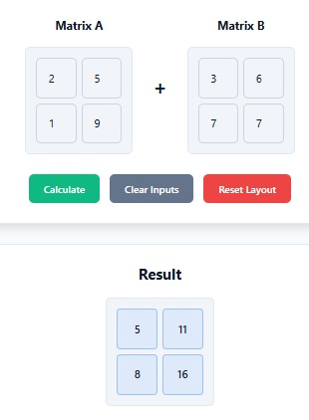
Addition Test

Figure 7. Matrix Calculator – Addition For Matrix A = [[2, 5], [1, 9]] and Matrix B = [[3,6], [7, 7]], the expected result is [[5, 11], [8, 16]].
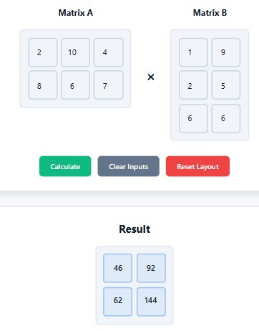
Multiplication Test
Figure 8. Matrix Calculator – Multiplication
For Matrix A = [[2, 10,4], [8, 6,7]] and Matrix B = [[1, 9], [2, 5],[6,6]], the expected result is [[46, 92], [62, 144]].
Transpose Test
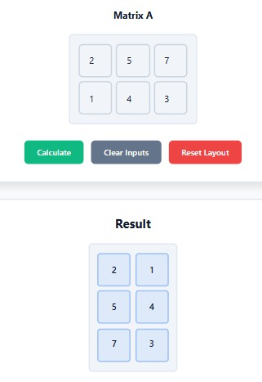

Figure 9. Matrix Calculator – Transpose
For Matrix A = [[2, 5, 7], [1, 4, 3]], the expected transpose is [[2, 1], [5, 4], [7, 3]].

Invalid Input Tests
The system should reject a 2×2 matrix added to a 2×3 matrix. It should also reject multiplication of a 2×3 matrix by a 2×2 matrix because the inner dimensions do not match.
The final documentation should include screenshots of the actual implemented calculator pages and their results. Screenshots should show at least one valid calculation for each supported operation and one invalid-input example.

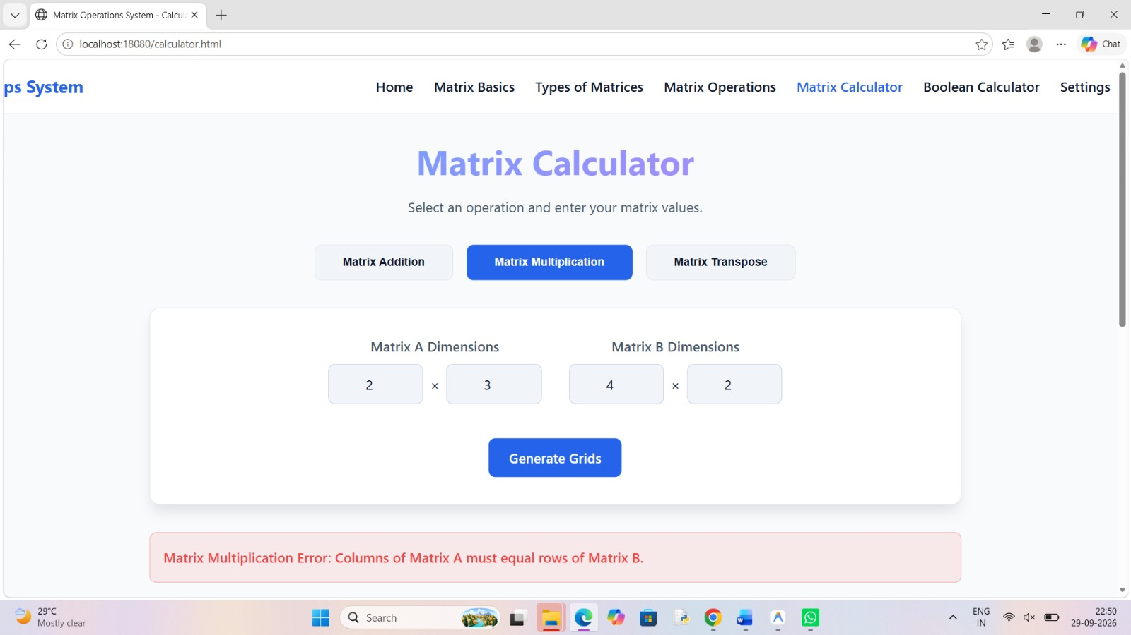
Figure 10. Invalid Input / Validation Result

CHAPTER – 3 CONCLUSION & FUTURE SCOPE
3.1 Conclusion
The Matrix Operations System provides an integrated platform for learning matrix concepts and performing selected matrix calculations. The project combines educational explanations with a practical web interface, allowing users to move from mathematical definitions to actual computation.
The C++ backend demonstrates how Object Oriented Programming can be applied to a real application. The Matrix class encapsulates matrix state and behavior, while constructors, member functions, private data members and exception handling contribute to a modular and maintainable implementation.
The project also demonstrates frontend–backend integration. JavaScript creates the user input interface and sends JSON requests, while Crow routes those requests to C++ functions and returns JSON responses. Validation is performed before computation so that incompatible matrices and malformed input are handled through clear error responses.
The current uploaded source implements conventional Matrix Addition, Matrix Multiplication and Matrix Transpose, along with Boolean Matrix Addition, Boolean Matrix Subtraction and Boolean Matrix Multiplication. The educational pages additionally introduce broader matrix operations such as determinant and inverse as mathematical topics.
The modular structure provides a foundation for future mathematical operations and enhanced learning features without requiring a complete redesign of the application.
Key Outcomes
- A reusable Matrix class with dynamic two-dimensional storage.
- REST API integration between a browser frontend and C++ backend.
- Dimension and input validation using C++ exceptions.
- Educational coverage of matrix fundamentals and 18 matrix types.
- Separate conventional and Boolean matrix calculation interfaces.
- CMake-based build configuration and Docker-based deployment support.
3.2 Future Scope
Add Matrix Subtraction and Scalar Multiplication to the conventional calculator API.
Implement determinant calculation for square matrices.
Add matrix inverse with non-singularity checks.
- Introduce rank and trace calculations.
- Add eigenvalues and eigenvectors as advanced matrix features.
- Extend Boolean matrix functionality with additional educational examples and validation.
- Store calculation history so users can review previous results.
- Allow results to be exported to text or other common formats.
- Add more visual examples, interactive explanations and guided exercises.
- Introduce an automated quiz or grading module for matrix concepts.
- Expand automated test coverage for larger matrices and edge cases.
- Introduce persistent user accounts and server-side storage if authentication becomes a required project feature.
Recommended Development Direction
Future development can proceed incrementally. Mathematical operations can first be added to the Matrix class and corresponding REST routes, followed by frontend controls and test cases. Educational features such as quizzes and worked examples can then be integrated without changing the core matrix representation.
Limitations of the Current Version
The uploaded README describes a smaller operation set than the current source tree; this documentation follows the current C++ source for implemented Boolean endpoints.
The supplied documentation package does not contain actual runtime screenshots of the application, so screenshots have not been invented in this report.
Authentication-related HTML pages are present in the frontend, but the supplied C++ backend source does not implement database-backed user authentication.

REFERENCES
1. Uploaded Matrix Operations System project source: backend/Matrix.h, backend/Matrix.cpp and backend/main.cpp.
2. Uploaded Matrix Operations System frontend source: HTML, CSS and JavaScript files included in Matrix_Operations_Project.zip.
3. Uploaded README.md – Matrix Operations System v3.0 project description, objectives, technology stack, build instructions and API examples.
4. Uploaded CMakeLists.txt files – C++17 project configuration and backend build structure.
5. Uploaded Dockerfile – Ubuntu-based build and execution configuration for the C++ backend.
6. Aditya University OOPS PBL Final Documentation Template – organization and academic documentation structure.
7. Course material and classroom notes for Object Oriented Programming through C++.
8. C++ Standard Library reference material for vector containers, classes, exceptions and standard programming constructs.
9. Crow C++ framework concepts used for HTTP routing, middleware and JSON handling.
10. Standard mathematics reference material covering matrix definitions, properties and operations.

C++ SOURCE CODE
backend/Matrix.h
Matrix class declaration
#ifndef MATRIX_H
#define MATRIX_H
#include <vector>
#include <stdexcept>
#include <string>
class Matrix {
private:
int rows;
int cols;
std::vector<std::vector<double>> data;
public:
// Constructors
Matrix();
Matrix(int rows, int cols);
Matrix(const std::vector<std::vector<double>>& grid);
// Getters
int getRows() const;
int getCols() const;
const std::vector<std::vector<double>>& getData() const;
// Core Operations
Matrix add(const Matrix& other) const;
Matrix multiply(const Matrix& other) const;
Matrix transpose() const;
// Boolean Operations
Matrix booleanAdd(const Matrix& other) const;
Matrix booleanSubtract(const Matrix& other) const;
Matrix booleanMultiply(const Matrix& other) const;
};
#endif // MATRIX_H

backend/Matrix.cpp
Matrix class implementation and all conventional/Boolean operations
#include "Matrix.h"
// Default constructor
Matrix::Matrix() : rows(0), cols(0) {}
// Constructor with dimensions
Matrix::Matrix(int r, int c) : rows(r), cols(c) {
if (r <= 0 || c <= 0) {
throw std::invalid_argument("Matrix dimensions must be strictly positive.");
}
// Prevent excessively large matrices to protect server memory
if (r > 1000 || c > 1000) {
throw std::invalid_argument("Matrix dimensions exceed the maximum allowed limit (1000x1000).");
}
data.assign(r, std::vector<double>(c, 0.0));
}
// Constructor with existing 2D vector data
Matrix::Matrix(const std::vector<std::vector<double>>& grid) {
if (grid.empty() || grid[0].empty()) {
throw std::invalid_argument("Cannot create an empty matrix.");
}
rows = grid.size();
cols = grid[0].size();
// Validate that all rows have the same number of columns
for (const auto& row : grid) {
if (row.size() != static_cast<size_t>(cols)) {
throw std::invalid_argument("Inconsistent number of columns in the provided grid.");
}
}
if (rows > 1000 || cols > 1000) {
throw std::invalid_argument("Matrix dimensions exceed the maximum allowed limit (1000x1000).");
}
data = grid;
}
// Getters
int Matrix::getRows() const {
return rows;
}
int Matrix::getCols() const {
return cols;
}
const std::vector<std::vector<double>>& Matrix::getData() const {
return data;
}
// Matrix Addition
Matrix Matrix::add(const Matrix& other) const {
if (this->rows != other.getRows() || this->cols != other.getCols()) {
throw std::invalid_argument("Matrix Addition Error: Both matrices must have the same dimensions.");
}
Matrix result(this->rows, this->cols);
for (int i = 0; i < this->rows; ++i) {
for (int j = 0; j < this->cols; ++j) {
result.data[i][j] = this->data[i][j] + other.data[i][j];
}
}
return result;
}
// Matrix Multiplication
Matrix Matrix::multiply(const Matrix& other) const {
if (this->cols != other.getRows()) {
throw std::invalid_argument("Matrix Multiplication Error: Columns of Matrix A must equal rows of Matrix B.");
}
Matrix result(this->rows, other.getCols());
for (int i = 0; i < this->rows; ++i) {
for (int j = 0; j < other.getCols(); ++j) {
double sum = 0.0;
for (int k = 0; k < this->cols; ++k) {
sum += this->data[i][k] * other.data[k][j];
}
result.data[i][j] = sum;
}
}
return result;
}
// Matrix Transpose
Matrix Matrix::transpose() const {
Matrix result(this->cols, this->rows);
for (int i = 0; i < this->rows; ++i) {
for (int j = 0; j < this->cols; ++j) {
result.data[j][i] = this->data[i][j];
}
}
return result;
}
// Boolean Addition (Logical OR)
Matrix Matrix::booleanAdd(const Matrix& other) const {
if (this->rows != other.getRows() || this->cols != other.getCols()) {
throw std::invalid_argument("Matrix Addition Error: Both matrices must have the same dimensions.");
}
Matrix result(this->rows, this->cols);
for (int i = 0; i < this->rows; ++i) {
for (int j = 0; j < this->cols; ++j) {
bool a = this->data[i][j] != 0;
bool b = other.data[i][j] != 0;
result.data[i][j] = (a || b) ? 1.0 : 0.0;
}
}
return result;
}
// Boolean Subtraction (Logical Difference: A AND NOT B)
Matrix Matrix::booleanSubtract(const Matrix& other) const {
if (this->rows != other.getRows() || this->cols != other.getCols()) {
throw std::invalid_argument("Matrix Subtraction Error: Both matrices must have the same dimensions.");
}
Matrix result(this->rows, this->cols);
for (int i = 0; i < this->rows; ++i) {
for (int j = 0; j < this->cols; ++j) {
bool a = this->data[i][j] != 0;
bool b = other.data[i][j] != 0;
result.data[i][j] = (a && !b) ? 1.0 : 0.0;
}
}
return result;
}
// Boolean Multiplication (Logical AND sum)
Matrix Matrix::booleanMultiply(const Matrix& other) const {
if (this->cols != other.getRows()) {
throw std::invalid_argument("Matrix Multiplication Error: Columns of Matrix A must equal rows of Matrix B.");
}
Matrix result(this->rows, other.getCols());
for (int i = 0; i < this->rows; ++i) {
for (int j = 0; j < other.getCols(); ++j) {
bool sum = false;
for (int k = 0; k < this->cols; ++k) {
bool a = this->data[i][k] != 0;
bool b = other.data[k][j] != 0;
if (a && b) {
sum = true;
break;
}
}
result.data[i][j] = sum ? 1.0 : 0.0;
}
}
return result;
}

backend/CMakeLists.txt
Backend C++ build configuration
cmake_minimum_required(VERSION 3.15)
include(FetchContent)
# Fetch Asio (required by Crow)
FetchContent_Declare(
asio
URL https://github.com/chriskohlhoff/asio/archive/refs/tags/asio-1-30-2.zip
)
FetchContent_MakeAvailable(asio)
list(APPEND CMAKE_PREFIX_PATH "${asio_SOURCE_DIR}")
include_directories("${asio_SOURCE_DIR}/asio/include")
set(CROW_BUILD_EXAMPLES OFF CACHE BOOL "" FORCE)
set(CROW_BUILD_TESTS OFF CACHE BOOL "" FORCE)
# Fetch Crow framework
FetchContent_Declare(
Crow
URL https://github.com/CrowCpp/Crow/archive/refs/tags/v1.2.0.zip
)
FetchContent_MakeAvailable(Crow)
# Declare our backend executable
add_executable(matrix_backend main.cpp Matrix.cpp Matrix.h)
# Link Crow to our executable
target_link_libraries(matrix_backend PRIVATE Crow::Crow)
if (WIN32)
target_link_libraries(matrix_backend PRIVATE ws2_32 mswsock)
endif()

backend/main.cpp
Crow REST API, JSON parsing/serialization, CORS and server startup
#include "crow.h"
#include "Matrix.h"
#include <vector>
#include <stdexcept>
// Helper to convert crow::json::rvalue to std::vector<std::vector<double>>
std::vector<std::vector<double>> parseMatrixJson(const crow::json::rvalue& json_matrix) {
if (json_matrix.t() != crow::json::type::List) {
throw std::invalid_argument("Matrix data must be a 2D array.");
}
std::vector<std::vector<double>> grid;
for (const auto& row : json_matrix) {
if (row.t() != crow::json::type::List) {
throw std::invalid_argument("Matrix row must be an array.");
}
std::vector<double> current_row;
for (const auto& val : row) {
if (val.t() != crow::json::type::Number) {
throw std::invalid_argument("Matrix values must be numeric.");
}
current_row.push_back(val.d());
}
grid.push_back(current_row);
}
return grid;
}
// Helper to convert std::vector<std::vector<double>> to crow::json::wvalue
crow::json::wvalue serializeMatrixJson(const std::vector<std::vector<double>>& grid) {
crow::json::wvalue::list matrix_list;
for (const auto& row : grid) {
crow::json::wvalue::list row_list;
for (double val : row) {
row_list.push_back(val);
}
matrix_list.push_back(std::move(row_list));
}
return crow::json::wvalue(std::move(matrix_list));
}
// Middleware to handle CORS
struct CORSHandler {
struct context {};
void before_handle(crow::request& req, crow::response& res, context& ctx) {}
void after_handle(crow::request& req, crow::response& res, context& ctx) {
res.add_header("Access-Control-Allow-Origin", "*");
res.add_header("Access-Control-Allow-Methods", "GET, POST, OPTIONS");
res.add_header("Access-Control-Allow-Headers", "Content-Type");
}
};
int main() {
crow::App<CORSHandler> app;
// OPTIONS route for all /api endpoints to handle CORS preflight
CROW_ROUTE(app, "/api/<path>").methods(crow::HTTPMethod::OPTIONS)([](std::string path) {
return crow::response(204);
});
CROW_ROUTE(app, "/api/add").methods(crow::HTTPMethod::POST)([](const crow::request& req){
auto body = crow::json::load(req.body);
if (!body) {
return crow::response(400, "Invalid JSON.");
}
try {
if (!body.has("matrixA") || !body.has("matrixB")) {
throw std::invalid_argument("Missing matrixA or matrixB.");
}
auto gridA = parseMatrixJson(body["matrixA"]);
auto gridB = parseMatrixJson(body["matrixB"]);
Matrix matA(gridA);
Matrix matB(gridB);
Matrix resultMat = matA.add(matB);
crow::json::wvalue response;
response["success"] = true;
response["result"] = serializeMatrixJson(resultMat.getData());
return crow::response(200, response);
} catch (const std::exception& e) {
crow::json::wvalue response;
response["success"] = false;
response["error"] = e.what();
return crow::response(400, response);
}
});
CROW_ROUTE(app, "/api/multiply").methods(crow::HTTPMethod::POST)([](const crow::request& req){
auto body = crow::json::load(req.body);
if (!body) {
return crow::response(400, "Invalid JSON.");
}
try {
if (!body.has("matrixA") || !body.has("matrixB")) {
throw std::invalid_argument("Missing matrixA or matrixB.");
}
auto gridA = parseMatrixJson(body["matrixA"]);
auto gridB = parseMatrixJson(body["matrixB"]);
Matrix matA(gridA);
Matrix matB(gridB);
Matrix resultMat = matA.multiply(matB);
crow::json::wvalue response;
response["success"] = true;
response["result"] = serializeMatrixJson(resultMat.getData());
return crow::response(200, response);
} catch (const std::exception& e) {
crow::json::wvalue response;
response["success"] = false;
response["error"] = e.what();
return crow::response(400, response);
}
});
CROW_ROUTE(app, "/api/transpose").methods(crow::HTTPMethod::POST)([](const crow::request& req){
auto body = crow::json::load(req.body);
if (!body) {
return crow::response(400, "Invalid JSON.");
}
try {
if (!body.has("matrix")) {
throw std::invalid_argument("Missing matrix.");
}
auto grid = parseMatrixJson(body["matrix"]);
Matrix mat(grid);
Matrix resultMat = mat.transpose();
crow::json::wvalue response;
response["success"] = true;
response["result"] = serializeMatrixJson(resultMat.getData());
return crow::response(200, response);
} catch (const std::exception& e) {
crow::json::wvalue response;
response["success"] = false;
response["error"] = e.what();
return crow::response(400, response);
}
});
CROW_ROUTE(app, "/api/bool_add").methods(crow::HTTPMethod::POST)([](const crow::request& req){
auto body = crow::json::load(req.body);
if (!body) return crow::response(400, "Invalid JSON.");
try {
if (!body.has("matrixA") || !body.has("matrixB")) throw std::invalid_argument("Missing matrixA or matrixB.");
Matrix matA(parseMatrixJson(body["matrixA"]));
Matrix matB(parseMatrixJson(body["matrixB"]));
Matrix resultMat = matA.booleanAdd(matB);
crow::json::wvalue response;
response["success"] = true;
response["result"] = serializeMatrixJson(resultMat.getData());
return crow::response(200, response);
} catch (const std::exception& e) {
crow::json::wvalue response;
response["success"] = false;
response["error"] = e.what();
return crow::response(400, response);
}
});
CROW_ROUTE(app, "/api/bool_sub").methods(crow::HTTPMethod::POST)([](const crow::request& req){
auto body = crow::json::load(req.body);
if (!body) return crow::response(400, "Invalid JSON.");
try {
if (!body.has("matrixA") || !body.has("matrixB")) throw std::invalid_argument("Missing matrixA or matrixB.");
Matrix matA(parseMatrixJson(body["matrixA"]));
Matrix matB(parseMatrixJson(body["matrixB"]));
Matrix resultMat = matA.booleanSubtract(matB);
crow::json::wvalue response;
response["success"] = true;
response["result"] = serializeMatrixJson(resultMat.getData());
return crow::response(200, response);
} catch (const std::exception& e) {
crow::json::wvalue response;
response["success"] = false;
response["error"] = e.what();
return crow::response(400, response);
}
});
CROW_ROUTE(app, "/api/bool_multiply").methods(crow::HTTPMethod::POST)([](const crow::request& req){
auto body = crow::json::load(req.body);
if (!body) return crow::response(400, "Invalid JSON.");
try {
if (!body.has("matrixA") || !body.has("matrixB")) throw std::invalid_argument("Missing matrixA or matrixB.");
Matrix matA(parseMatrixJson(body["matrixA"]));
Matrix matB(parseMatrixJson(body["matrixB"]));
Matrix resultMat = matA.booleanMultiply(matB);
crow::json::wvalue response;
response["success"] = true;
response["result"] = serializeMatrixJson(resultMat.getData());
return crow::response(200, response);
} catch (const std::exception& e) {
crow::json::wvalue response;
response["success"] = false;
response["error"] = e.what();
return crow::response(400, response);
}
});
// Serve Static Frontend Files
CROW_ROUTE(app, "/")([](crow::response& res) {
res.set_static_file_info("frontend/index.html");
res.end();
});
CROW_ROUTE(app, "/<path>")([](crow::response& res, std::string path) {
res.set_static_file_info("frontend/" + path);
res.end();
});
// Support for Cloud Hosting (Render, Heroku, etc.)
const char* port_env = std::getenv("PORT");
int port = port_env ? std::stoi(port_env) : 18080;
// Start the server
app.port(port).multithreaded().run();
return 0;
}

